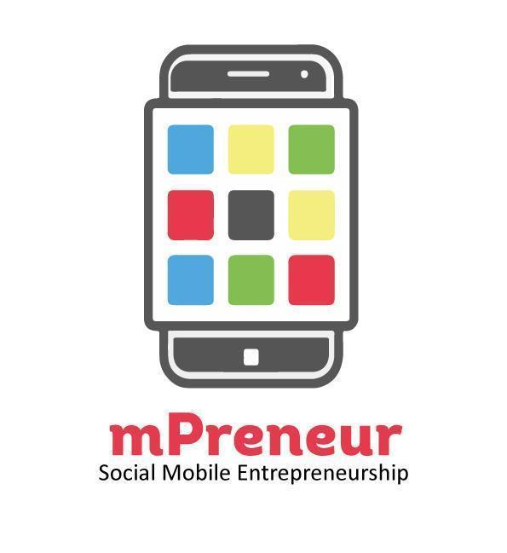
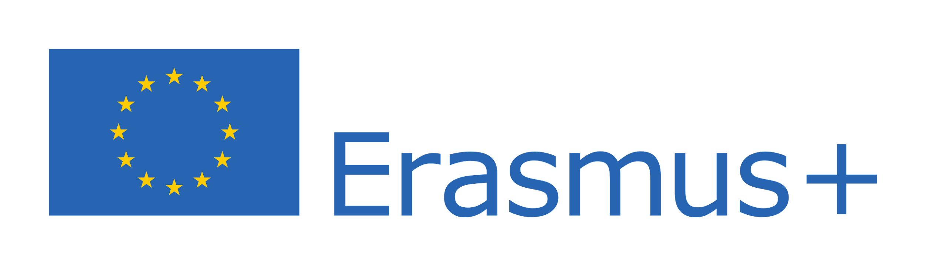

MOBILE ENTREPRENEURSHIP FOR SUSTAINABLE FUTURE (mPrenuer)
Application Form

Call for Applications 2022

Key Dates
International Business Training
Macedonia
March 2023

European Innovators Festival in
Austria
May 2023

National Camp
Uganda in Kampala.
Dates: 25-26/08/2022

Application
By
10th August 2022

Uganda Youth Skills Training Organization
P. O Box 72164 Clock Towers Kampala Uganda
150 meters off Kasubi tombs street behind St Andrew’s Church of Uganda
bobmaahe@gmail.com/info@skillsforyouths.org

Website: https://skillsforyouths.org/
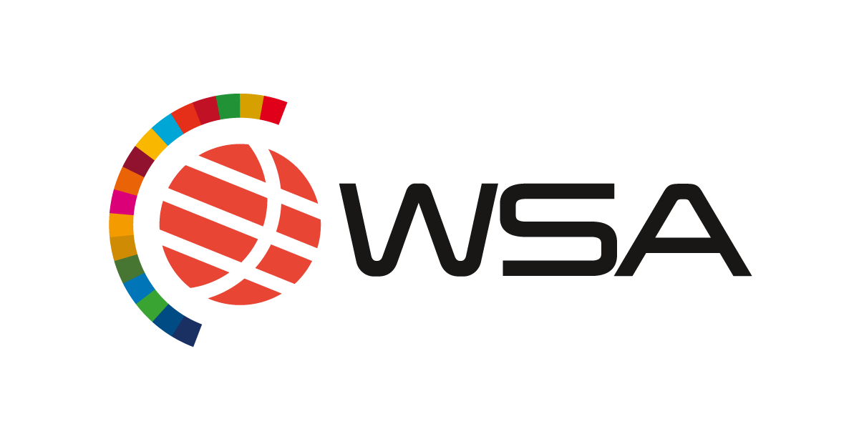
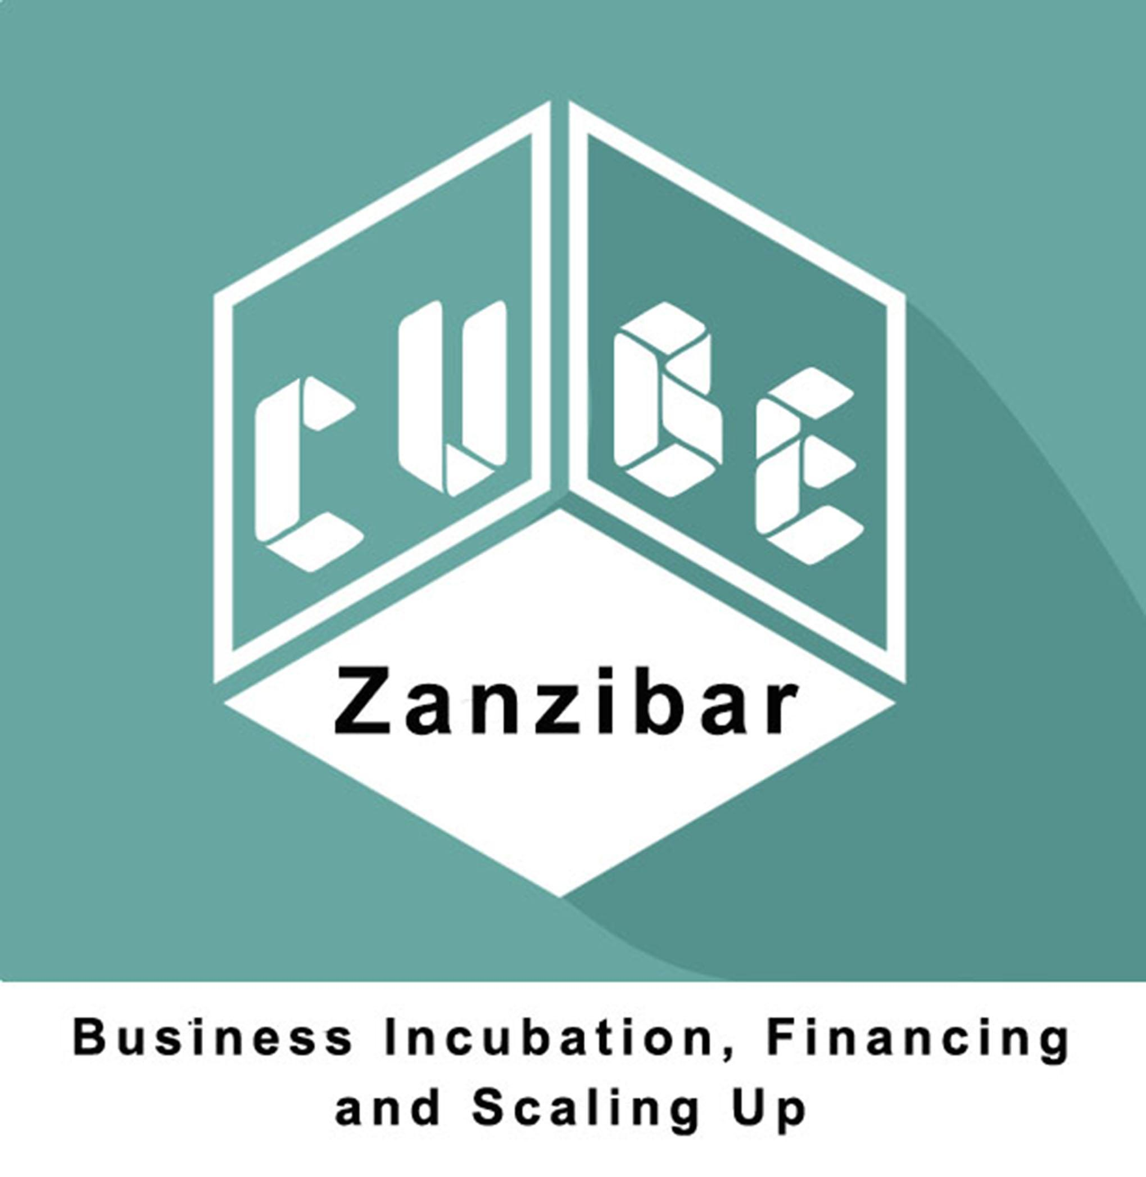
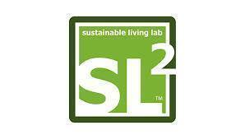
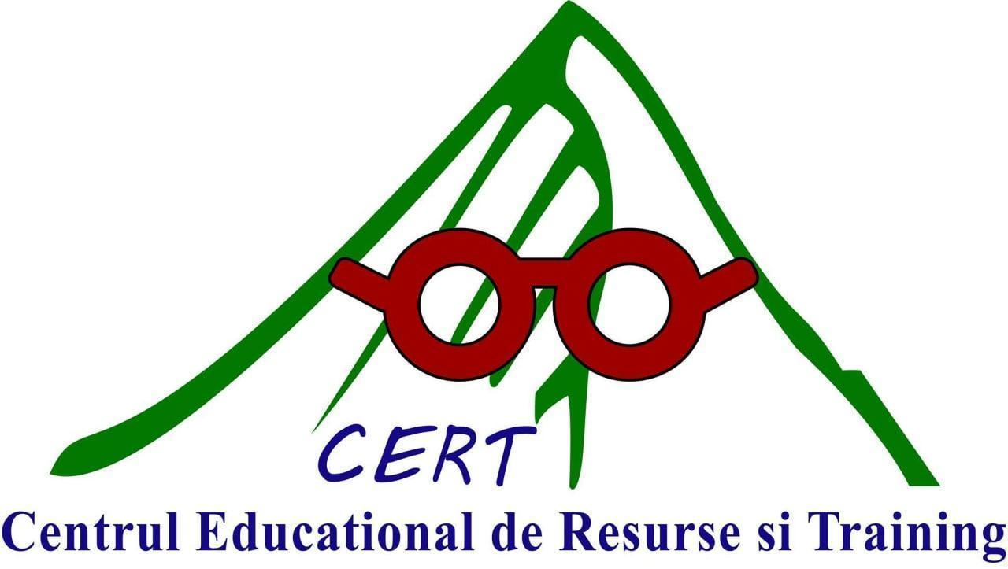
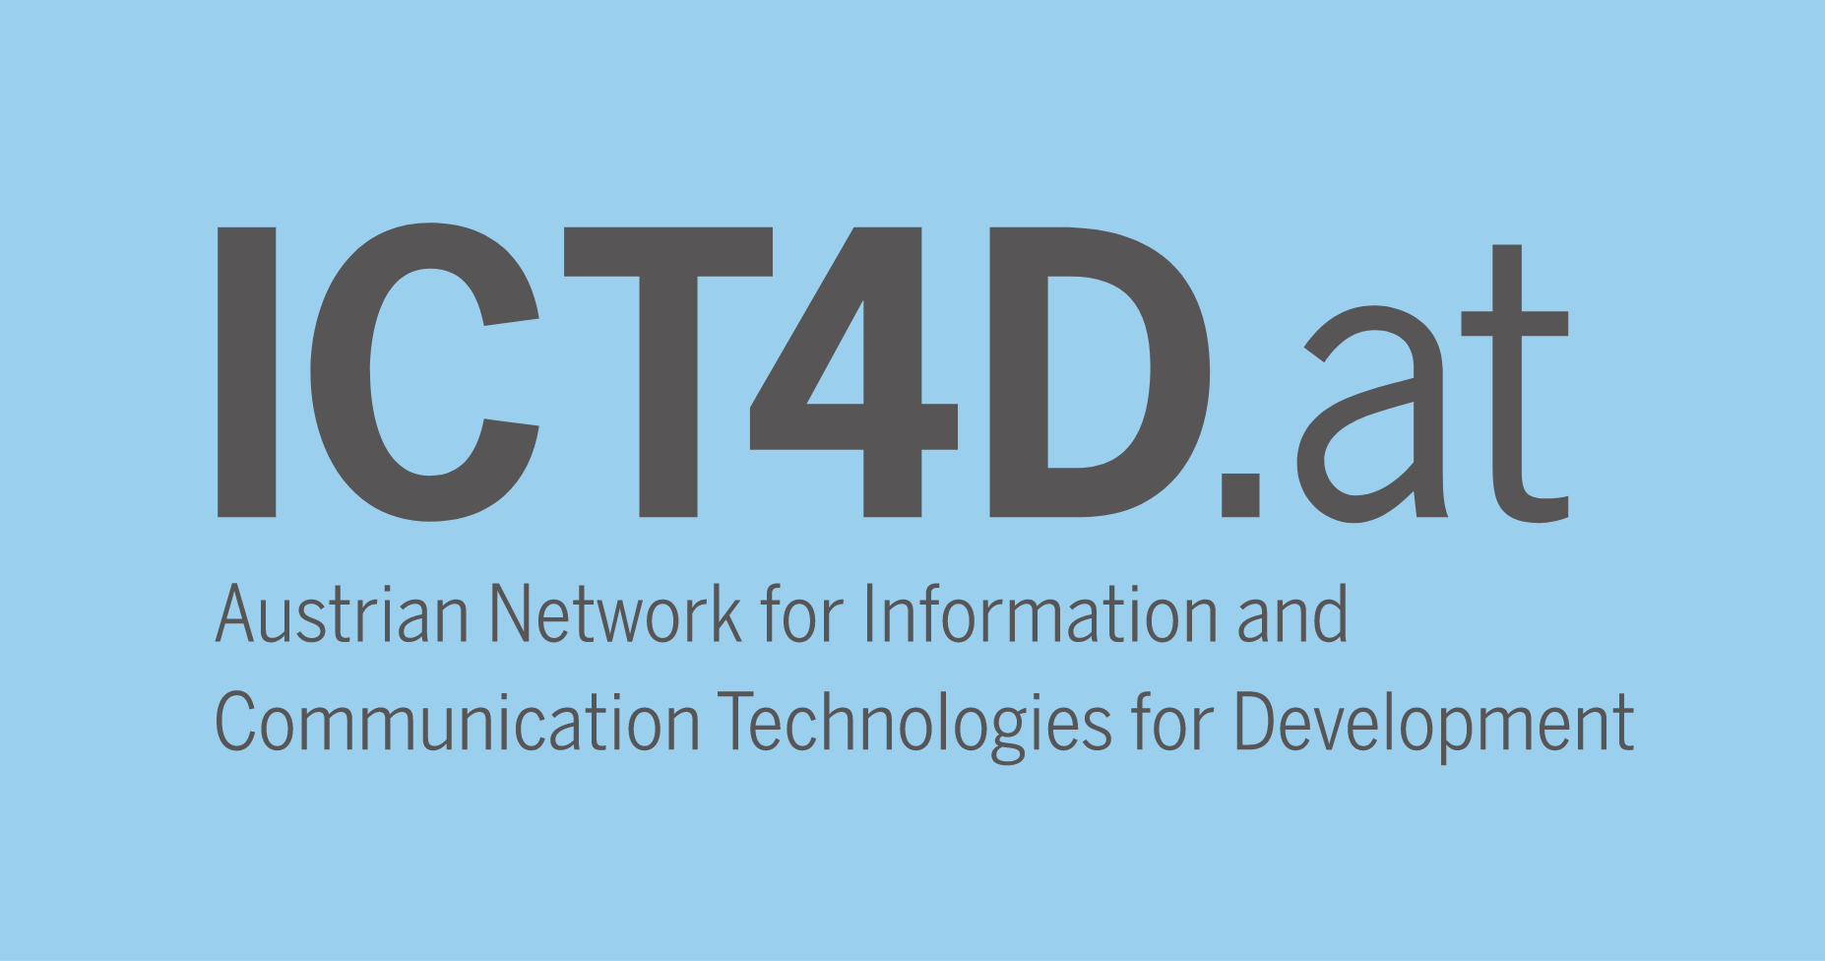

APPLICANT GUIDE

Please read carefully through the Call for Application before filling out this mPrenuer-Mobile Entrepreneurship for Sustainable Future Form. “The Call for Application” highlights the background of the mPrenuer project, the selection criteria, the selection process and other important information. Ensure that you answer all the questions to your best and more importantly, be brief, precise and to the point for clarity and at the same time include important details about your mobile app. Observe the character limits, formatting style and any other instructions provided. NOTE that any incomplete applications will automatically be disqualified. Please send your completed application to bobmaahe@gmail.com, and send a copy to info@skillsforyouths.org on or before Wednesday 10th August 2022 COB stating “mPrenuer [your app name]” as the subject of the submission email. Applications delivered outside the deadline will automatically be disqualified.

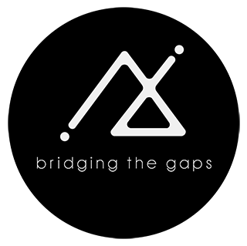
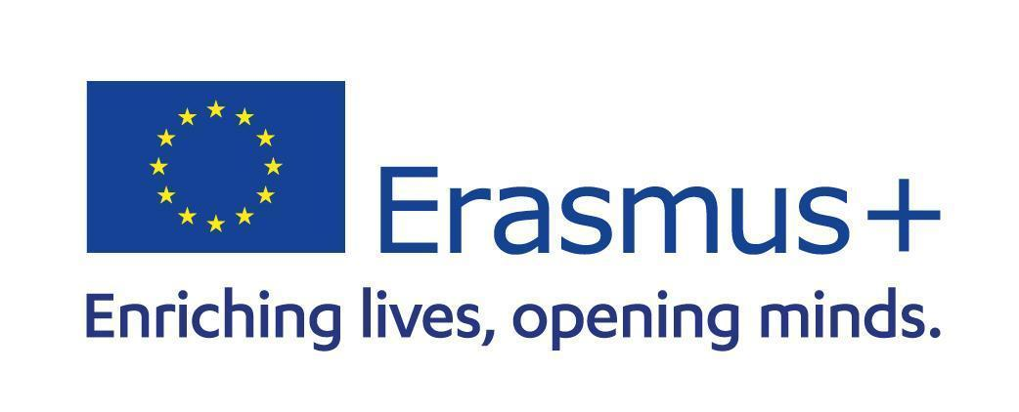

PART 1: APPLICANT INFORMATION

Contact Information of applying individuals/ or group co-founders
Name of mobile solution/App |  | Full name of the applicant
Organization Phone (If applicable) |  | His/her current position
Website address (if applicable) |  | Phone of contact person
E-mail address (can be applicants email) |  | Date of birth  dd/mm/yyyy
Which stage of development is your app?
Are you a Ugandan resident?
Yes

No
City where you currently live:
Organization type
Type of applying organization (tick as appropriate)
Individual

Business name

Partnership

Company

Community Based Organization

Non-Governmental Organization
Other please specify ……………………………………………………………………………………..

If you have a co-founder/ team member(s), kindly list their names, date of birth and email addresses. Maximum 5 members.
Full Names | Date of Birth  (dd/mm/yyyy | Email | Expertise e.g Programming, Design, business

In not more than 150 words, kindly give a brief description of your mobile app. What is your mobile app about?

Your Target Groups/Beneficiaries/Users.
In this section, you are required to indicate the population that your mobile app is reaching. Let us clearly understand your target market (s) (not more than 100 words)

Social Impact
In not more than 250 words, how has your mobile app impacted on the lives of the beneficiaries/your target group? Kindly demonstrate the social impact of your mobile app. Please give examples and numbers. We are interested on the mobile apps that have improved the wellbeing of the users/beneficiaries

Development Stage of the Mobile App
Is your mobile app/solution in beta version / pre-launch version / uploaded on App Store/Google Play? | Yes  No | If your app is in Beta version, do you consent to complete it and make it available to users by October 2022? | Yes  No
Is your mobile technology open for public view? | Yes  No

Problem definition:
In not more than a 100 words, what is the problem? What needs/challenges do these target groups face that your mobile app is addressing.

In not more than a 100 words, what needs assessment have you conducted, and what were the findings? How did you identify these needs and challenges above?
In not more than 100 words, how is the mobile app addressing the problem described above?

Competition:
Who are your direct and indirect competitors and what is your competitive advantage?

Creativity and Innovation
How is your mobile application/technology truly innovative and unique in your context? What makes your mobile app stand out? Bring out the value preposition.

Sustainability
What strategies have/will you put in place to ensure that the benefits of this mobile app continue to be felt now and beyond? How does your mobile app generate income?
If selected, do you consent to participate further on international Mobile Camp, Business Training and World Summit Award Competition?
Yes

No

What is your motivation to apply for this competition? (Not more than 100 words)

Please share links to platforms that represent your mobile App online. This includes website, Facebook, Instagram, LinkedIn etc.?

Attachments
Applicant must attach a maximum of 5 screenshots of the mobile app operation demo to this application.
Additionally, though not compulsory at this stage, the applicant can create a video demo and upload it on a YouTube Channel accessible by the jury.

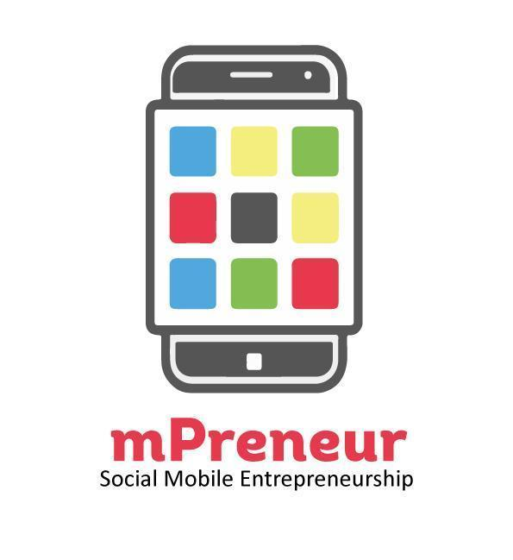

The mPrenuer project is particularly dedicated to provide space for youth that is already in the field of new technologies and develop further their potentials by providing them with new ways of personalized, learner-centered, situated, collaborative, ubiquitous, and lifelong learning.
http://www.myouth.eu

The European Youth Award (EYA) merged up with the World Summit Award (WSA) to better support innovators and entrepreneurs. The WSA is a unique awards system, selecting and promoting local digital innovation to improve society. Combining an ongoing series of international events and activities with a global network of start-ups, social entrepreneurs, mentors, jurors, speakers, experts, government leaders, academia and civil society, WSA is an international platform for cutting-edge examples of how ICTs can impact society in a positive way.

http://www.eu-youthaward.org/

